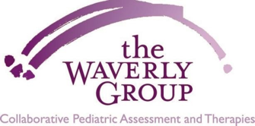

Photograph & Video Release Form

I hereby grant permission for The Waverly Group to videotape and/or photograph my child’s therapy session(s). Videotaping and photographing will be used for the clinical purpose of gathering information to further support my child’s improvement and growth at The Waverly Group. I understand that these videotapes and/or photographs will only be shared with Waverly Group clinicians and will never be copied, shared, published or distributed to anyone outside of The Waverly Group. I will always be consulted about the use of the video recording or photos for any purpose other than those listed above, and if additional use is requested, that request will be made in writing in a release form similar to this.

There is a one year time limit on the validity of this release.

By signing this form I acknowledge that I have completely read and fully understand the above release and agree to the terms.

Full Name ___________________________________________________

Relationship to child ________________________________________________

Signature____________________________ Date____________________________

If this release is obtained from a participant under the age of 18, then the signature of that participant’s parent or legal guardian is also required.

Parent’s Signature_____________________ Date____________________________

